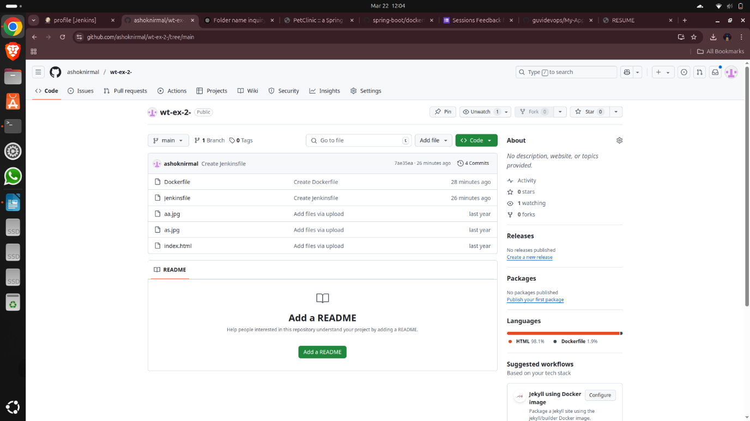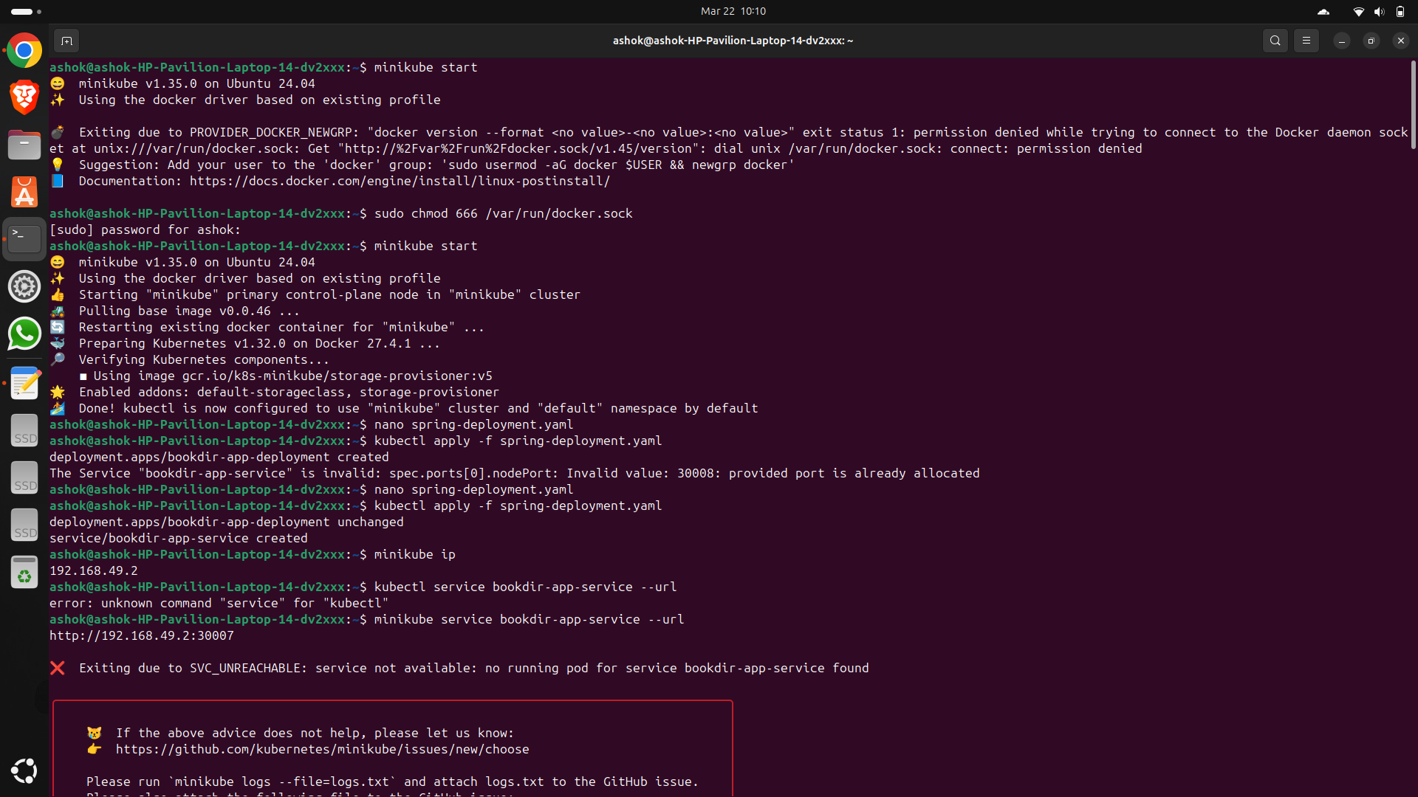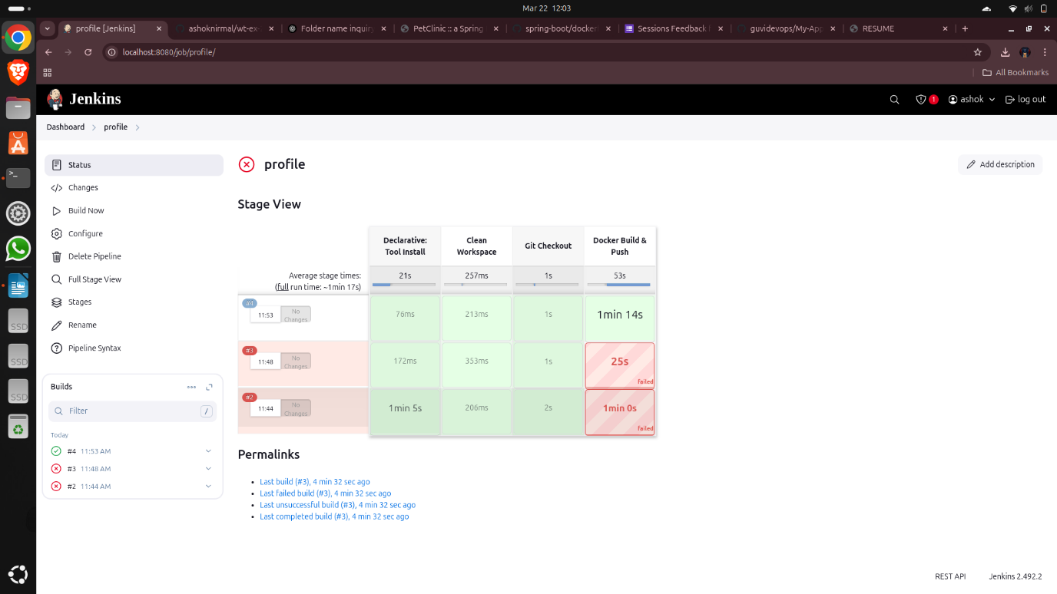

**service.yml:**

apiVersion: v1

kind: Service

metadata:

name: wt-ex-2-service # This should match your deployment

spec:

selector:

app: wt-ex-2 # Make sure this label matches your deployment

ports:

- protocol: TCP

port: 80 # External service port

targetPort: 80 # Port inside the container

type: NodePort

**commands:**

kubectl apply -f service.yml

kubectl get services

minikube service wt-ex-2-service --url

